**Prominent High Quality Office Accomodation**

**Suite 2 Penthouse , St Georges House, 2 St Georges Road, Bolton, BL1 2EN**

**2,100 ft² (195.09 m²)**

* Beautiful restored heritage building
* Refurbished to a high specification
* Great town centre location but minutes away the from motorway network
* Excellent transport links
* Flexible deals available
* Manned reception facilities
* Onsite café/bistro

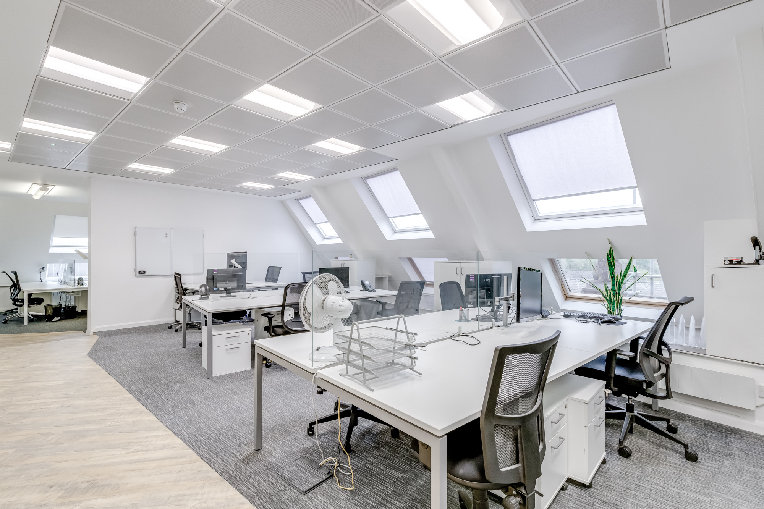

**Description**

The five storey property comprises an attractive, restored heritage building located in the Town Centre, with a mixture of cellular and open plan accommodation over all floors.

The ground floor provides a mix of office accommodation and meeting rooms, in addition to a state of the art Bistro and Art Gallery. Suite 2 is located on the top floor and provides premium penthouse accommodation and is fully fitted to a premium standard.

The refurbished building will provide spacious office accommodation, with generous facilities, in addition to attractive and imposing common areas, benefiting from the retained traditional features. The offices benefit from full double glazing, gas & electric heating and the building will benefit from a fully glazed passenger lift, accessing all floors.

**Location**

St George's House occupies a prominent corner position at the junction of Bridge Street and St George's Road in Bolton town centre. St George's Road is occupied by a mix of business operations, such as financial and professional services; medical consultation and general offices.

The building is located within walking distance of the town centre amenities and the A666 is located approximately 0.4 miles to the east of the property, which provides direct links to the M60 motorway network.

The Market Place, Top Way and All Saints Street public car parks are all located within walking distance of the building, together with all town centre facilities.

**Accommodation**

In accordance with the RICS Property Measurement 2nd Edition we have calculated the following floor areas on a net internal area basis:

195 sq m (2,100 sq ft**)**

**Rent and Lease Terms**

£28,500 Per annum exclusive of all other outgoings.

The lease will be held on full repairing and insuring lease for a term to be agreed.

There will be a service charge levied to cover the maintenance of the common areas and external apperance of the building. Further information can be provided upon request.

**Planning Use**

Use Class E Offices

**EPC**

A copy of the EPC is available on request.

**VAT**

VAT will be charged at the prevailing rate

**Business Rates**

Suite 2 has a retable value of £14,750 effective of 1st April 2023.

**Viewing**

By appointment through Fletcher CRE or the joint agents.

John Fletcher

01204 221 030

john.fletcher@fletchercre.co.uk

Fletcher CRE for themselves and for the vendors or lessors of the property give notice that these particulars do not constitute any part of an offer or contract. Any intending purchaser or tenant must satisfy, by inspection or otherwise, as to the condition of the premises and no warranty is given by the vendor, landlord, their agents or any person in the agent's employment. Comments in this description relating the location, suitability for any purpose, aesthetic attributes, functionality or existence of services and proximity to amenities to be regarded as the agent's opinion only and not a statement of fact. Sizes quoted are approximate and given as indication only.



